Virginia in bloom

It is officially springtime, which means warmer weather, beautiful greenery, flowers and the end of the college year. So many people look forward to being outside during the spring and making the most out of this gorgeous weather before it becomes too hot to be outside, the greenery turns brown, and all those gorgeous flowers go away. We must make the best of the time that we have! There are so many ways to do this and places to go. Today we will explore the various places to go in Harrisonburg and across Virginia.

[Harrisonburg](https://www.jmu.edu/arboretum/index.shtml)

In Harrisonburg and some close by local cities there are many things to do. We have the Edith J. Carrier Arboretum on East campus which is home to many flowers and plants. There are also some ducks that take walks around the pond located in the center of the arboretum. A little further away there are many hikes to take at Massanutten, or in Shenandoah National Park. If you are not quite a big hiker, like me, and are more interested in a driving view of the beautiful mountains, then Skyline Drive is the place for you. This is not too far from campus, and with sweeping views of the trees it is what really makes the valley lovely.

Edit J. Carrier Arboretum- Harrisonburg, Va Photo curtsey [JMU](https://www.jmu.edu/arboretum/index.shtml).

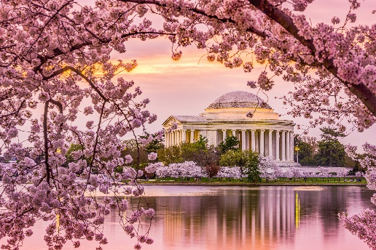[Washington D.C.](https://nationalcherryblossomfestival.org/)

The cherry blossom festival takes place every March all over our nation’s capital. The cherry blossoms are the signature of Washington D.C. and the whole city prepares for the festival by offering concerts, special events, restaurant week highlights and much more. The cherry blossoms are very delicate and only respond well to certain weather conditions. This makes it hard to see if you are only in town for a few days. The days of the festival change every year so make sure to keep a lookout for up-to-date information on these blooms.

Cherry blossoms across from the Jefferson memorial: Photo curtesy [Visit Montgomery](https://visitmontgomery.com/blog/experts-advice/history-of-the-cherry-blossoms-of-washington-dc/)

[Burnside Farms](https://www.burnsidefarms.com/spring)

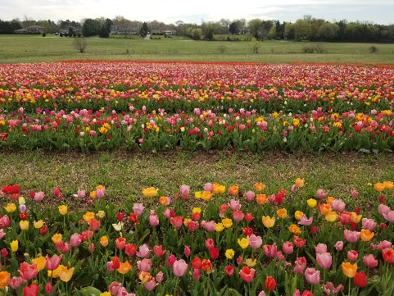 If you are looking for the famous tulips in Amsterdam but do not have the budget to fly overseas, then this is for you! In Nokesville, Virginia there is a farm that plants hundreds of tulips every year and they have them for the whole month of April. They are very picturesque and will make you feel like you are in the Netherlands. While the tulips do not last all spring, they have a special sunflower field for the summer months so that people can get their flower fix all summer long as well.

Tulips at Burnside Farms- Nokesville, Va. Photo Curtesy [Burnside Farms](https://www.burnsidefarms.com/spring)